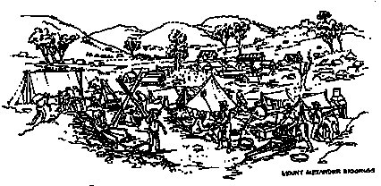

**What did the Goldfields look like?**

The goldfields were noisy,busy, colourful and most exciting.

There were,______ trees to be seen. For miles around the _______ had been stripped and the trees used as ______ poles, mine props and firewood. Heaps of earth were dotted everywhere and the once clear creeks were thick and yellow with mud.

Every person was ________ with mud. Clothes, hair and faces were yellow and sticky. Heads popped out of holes. Men using _______, axes and shovels attacked the soil. Others trundled wheelbarrows. Those without such luxuries pulled the soil along on a piece of sack _________ to wooden handles.

And always there was _______ . Men swearing, muttering, yelling, dogs barking, the occasional rowdiness of a _________ . And added to the noise of men and animals were the noises of mining, windlasses squeaking, the __________ of shovels and spades and the rattling and grating cradles.

But ________the yellow mud, the goldfields were alive with colour. Even the quartz __________ in the sunlight and flags of all colours fluttered. There were red flags signifying that a ________ had been made and flags of all shapes flew above offices and shops, often bearing the national symbol of the owner.

Most _______ lived in tents. You could tell the new chums from the old hands by the colour and ________ of the tent. If the tent was new and still white the miner, had ______ been on the fields long. Ragged, dirty tents ______________ an old hand .

Some miners built huts. Like the tents, they ranged from frail bark constructions to neat slab _______ with a solid roof.

_____________ was sparse and improvised. There would be a bunk or bed on the ________ earth, a cupboard and a seat made out a flour barrel. 0nly _________ miners owned anything more.

tent

not

land

clear

picks

noise

fight

bare

few

Furniture

indicated

condition

dwellings

sparkled

despite

scraping

wealthy

strike

miners

covered

attached

***Resize the words in the text boxes and cut and paste them into the correct places to complete the text***