How did Gold get there?

1. Alluvial gold is gold eroded away 2. Gold has sunk to bottom of river
from reefs, washed down into sediment and built up in crevices,
watercourses and river beds. It is against boulders or tree roots.
deposited where the current slows
- in river flats or bends

3. Alluvial gold is also found on sides 4. Where sediment has formed
of ancient river walls, trapped on thick layers, diggers sank shafts to tap
ledges of rock. the ancient river bed

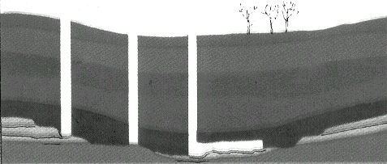
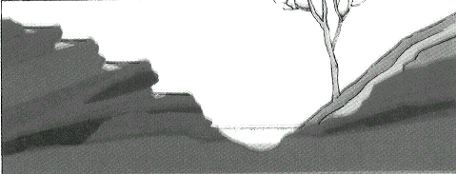
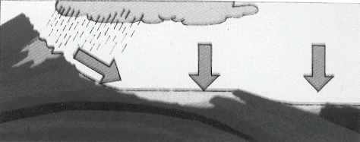
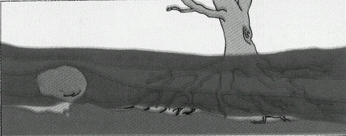
Drag the picture to the correct boxes above and save your document to your Gold folder in your Home folder

