Chinese Gold Miners
What percentage the Australian population were Chinese in 1861?
What did the Chinese immigrants call the Australian goldfields?
After the southern goldfields depleted, where did the Chinese miners go?
Why didn’t many Chinese miners bring their wives and family to Australia?
What did the Chinese miners do with the money they earned?
Why didn’t the Chinese miners like to mine underground?
Why did other miners distrust the Chinese miners?
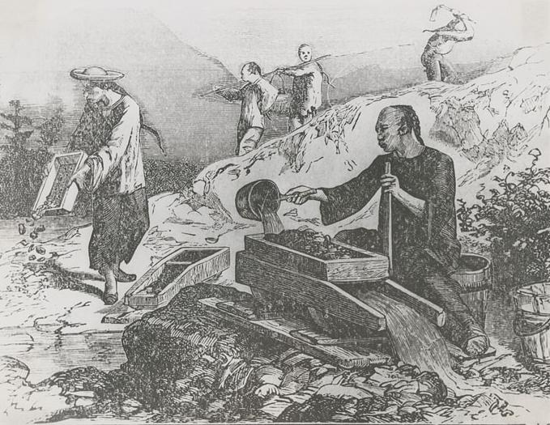
What did their resentment and rumours lead to?
What did the Victorian 1855 law, “An Act to Make Provision for Certain Immigrants” enact?
What town is Lambing Flat now known by?
There were several riots against the Chinese between 1860 and 1861, why is Lambing Flat so well known?
Write a paragraph about what happened?

